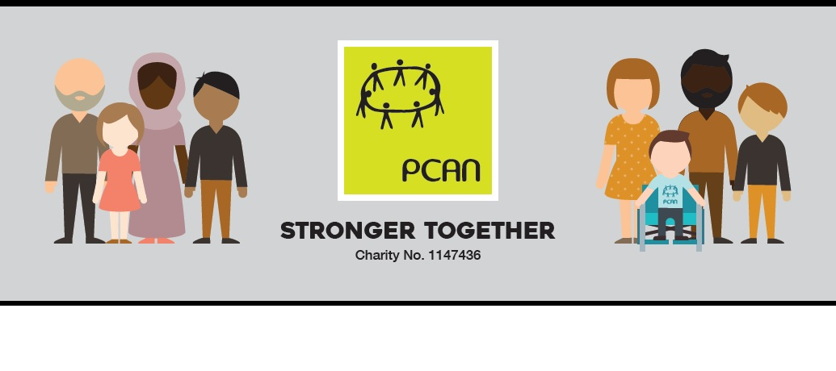Dear Parent
The Department of Health and Social Care and the Department of Education have launched a new pilot to upskill school staff to improve mainstream school experience for children with additional needs.
In Kirklees 14 primary schools have been chosen to take part and your school is one of them. Health partners are working with the Council and PCAN, the parent carer forum for Kirklees, to make this project happen.
Part of the project is to get the views of parents and carers so we would be really grateful if you could take the time to complete it, it will only take a few minutes. The survey is for everyone with children at this school to complete not just those who have children with additional needs. Please use the QR code below to access the survey:
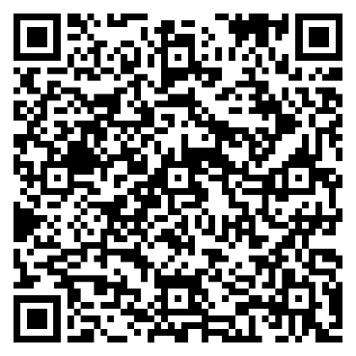

Thank you for your time!
Regards
The PCAN Team

